NAME: Shubhangi Balaji khavle(260640161192)
Kaveri Avinash Jarhad (260640160454)
Assignment no 1

------------------ Day 1----------------
1. Write a C++ program to create a namespace named Math that contains a function void square(int) to calculate the square of a number. Access the function using the scope resolution operator.

#include<iostream>
using namespace std;
namespace Math{
void square(int n){
cout<<"Square of a number="<<n*n;
}
}

int main(){
int n;
cout<<"Enter the number";
cin>>n;
Math::square(n);
return 0;
}

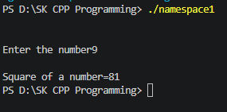

2.Create a namespace named Calculator containing the following functions:
add()
subtract()
multiply()
divide()
Write a menu-driven program to perform arithmetic operations using namespace functions.
#include <iostream>
using namespace std;

namespace Calculator {
void Add(int a, int b) {
cout << "Addition = " << a + b << endl;
}
void Sub(int a, int b) {
cout << "Subtraction = " << a - b << endl;
}
void Mul(int a, int b) {
cout << "Multiplication = " << a * b << endl;
}
void Div(int a, int b) {
if (b == 0) {
cout << "Error: Division by zero is not allowed!" << endl;
} else {
cout << "Division = " << static_cast<double>(a) / b << endl;
}
}
}

int main() {
int a, b, choice;

cout << "Enter two numbers: ";
cin >> a >> b;

cout << "\n1. Addition\n2. Subtraction\n3. Multiplication\n4. Division\n";
cout << "Enter your choice: ";
cin >> choice;

switch (choice) {
case 1:
Calculator::Add(a, b);
break;
case 2:
Calculator::Sub(a, b);
break;
case 3:
Calculator::Mul(a, b);
break;
case 4:
Calculator::Div(a, b);
break;
default:
cout << "Invalid choice! Please select a option between 1 and 4." << endl;
break;
}

return 0;
}

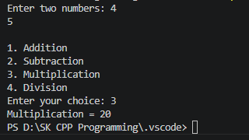

3.Create two namespaces:
Rectangle
Circle
The Rectangle namespace should calculate area of rectangle.
The Circle namespace should calculate area of circle.
Allow the user to select which area to calculate.
#include <iostream>
using namespace std;

namespace Rectangle {
void Area(float l, float b) {
cout << "Area of Rectangle = " << l * b << endl;
}
}
namespace Circle {
void Area(float r) {
cout << "Area of Circle = " << 3.14*r*r << endl;
}
}

int main() {
int choice;

cout << "\n1. Rectangle\n2. Circle\n";
cout << "Enter your choice: ";
cin >> choice;

if(choice==1){
float l, b;
cout<<"Enter the length and breadth:";
cin>>l>>b;
Rectangle::Area(l, b);
}
else if(choice==2){
float r;
cout<<"Enter the Radius:";
cin>>r;
Circle::Area(r);
}
else{
cout<<"Invalid choice";
}
}

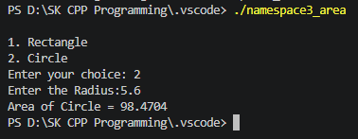

4. Create two namespaces:
namespace India
namespace USA
Each namespace should have a function named currency().
#include <iostream>
using namespace std;

namespace India {
void Currency() {
cout << "Currency of India is Rupee" << endl;
}
}

namespace USA {
void Currency() {
cout << "Currency of USA is Dollar" << endl;
}
}

int main() {
India::Currency();
USA::Currency();

return 0;
}

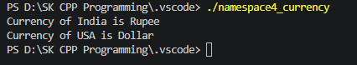

5.Create a namespace named Student having
rollNo
name
display()
Use the using namespace directive to access members without using scope resolution operator.
#include <iostream>
#include <string>
using namespace std;

namespace Student {
int rollNo = 101;
string name = "pooja";

void display() {
cout << "Roll Number: " << rollNo << endl;
cout << "Name: " << name << endl;
}
}

using namespace Student;

int main() {
display();

rollNo = 11;
name = "kaveri";

cout << "\nUpdated Student Details:" << endl;
display();

return 0;
}

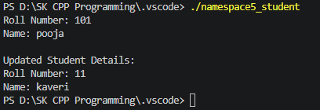
6. Write a C++ program that dynamically allocates memory for storing the marks of a student based on the number of subjects entered by the user.
The program should perform the following tasks:
1. Accept the number of subjects from the user.
2. Dynamically allocate memory to store the marks of all subjects.
3. Accept the marks for each subject.
4. Display the marks of all subjects.
5. Calculate and display the total (sum) of the marks.
6. Calculate and display the average marks obtained.
7. Deallocate the dynamically allocated memory before the program terminates to avoid memory leaks.

#include <iostream>
using namespace std;

int main() {
int sub, *marks, sum = 0;
float avg;

cout << "Enter the number of subjects: ";
cin >> sub;

if (sub <= 0) {
cout << "Invalid number of subjects!" << endl;
return 1;
}

marks = new int[sub];

cout << "\nEnter marks for " << sub << " subjects:\n";
for (int i = 0; i < sub; i++) {
cout << "Subject " << (i + 1) << ": ";
cin >> marks[i];
sum += marks[i];
}

cout << "\n--- Displaying Marks ---" << endl;
for (int i = 0; i < sub; i++) {
cout << "Subject " << (i + 1) << ": " << marks[i] << endl;
}

avg = static_cast<float>(sum) / sub;
cout << "\nTotal Marks (Sum): " << sum << endl;
cout << "Average Marks: " << avg << endl;

delete[] marks;
marks = nullptr;

return 0;
}

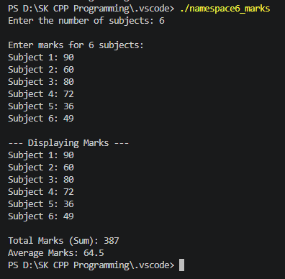

7. Write a C++ program that dynamically allocates memory for a 2D array to store the marks of multiple students in multiple subjects.
The program should perform the following tasks:
1. Accept the number of students from the user.
2. Accept the number of subjects from the user.
3. Dynamically allocate memory for a 2D array of size Students × Subjects.
4. Accept the marks of each student in every subject.
5. Display the marks in tabular format.
6. Calculate and display the total and average marks for each student.
7. Calculate and display the highest mark obtained among all students.
8. Deallocate all dynamically allocated memory before the program terminates to prevent memory leaks.
#include <iostream>
#include <iomanip>
using namespace std;

int main() {
int numStudents, numSubjects;

cout << "Enter the number of students: ";
cin >> numStudents;
cout << "Enter the number of subjects: ";
cin >> numSubjects;

if (numStudents <= 0 || numSubjects <= 0) {
cout << "Invalid input! Number of students and subjects must be greater than 0." << endl;
return 1;
}

int** marks = new int*[numStudents];
for (int i = 0; i < numStudents; i++) {
marks[i] = new int[numSubjects];
}

for (int i = 0; i < numStudents; i++) {
cout << "\nEnter marks for Student " << (i + 1) << ":\n";
for (int j = 0; j < numSubjects; j++) {
cout << " Subject " << (j + 1) << ": ";
cin >> marks[i][j];
}
}

int highestMark = marks[0][0];

cout << "\n--- Marks Table ---\n";
cout << setw(10) << "Student";
for (int j = 0; j < numSubjects; j++) {
cout << setw(10) << ("Sub " + to_string(j + 1));
}
cout << setw(10) << "Total" << setw(12) << "Average" << endl;

for (int i = 0; i < numStudents; i++) {
int studentTotal = 0;

cout << setw(10) << ("Student " + to_string(i + 1));
for (int j = 0; j < numSubjects; j++) {
cout << setw(10) << marks[i][j];
studentTotal += marks[i][j];

if (marks[i][j] > highestMark) {
highestMark = marks[i][j];
}
}

double studentAvg = static_cast<double>(studentTotal) / numSubjects;
cout << setw(10) << studentTotal << setw(12) << fixed << setprecision(2) << studentAvg << endl;
}

cout << "\nHighest mark obtained among all students: " << highestMark << endl;

for (int i = 0; i < numStudents; i++) {
delete[] marks[i];
}
delete[] marks;
marks = nullptr;

return 0;
}

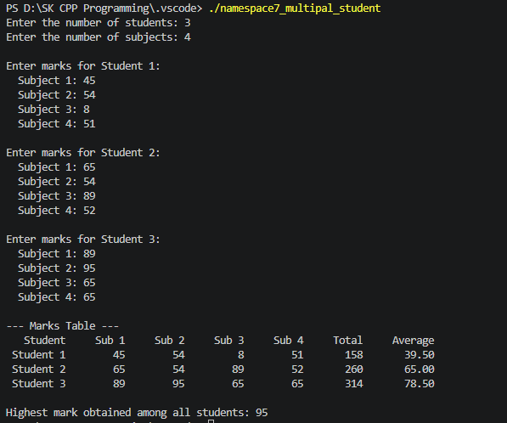
8. Write a C++ program that dynamically allocates a 2D array to store the monthly sales of different products.
The program should:
1. Accept the number of products.
2. Accept the number of months.
3. Store the sales data.
4. Display the sales report.
5. Calculate:
Total sales of each product.
Total sales for each month.
Grand total of all sales.
Deallocate the memory.
#include <iostream>
using namespace std;

int main()
{
int products, months;

cout << "Enter number of products: ";
cin >> products;

cout << "Enter number of months: ";
cin >> months;

int **sales = new int *[products];

for (int i = 0; i < products; i++)
{
sales[i] = new int[months];
}

cout << "\nEnter Sales:\n";

for (int i = 0; i < products; i++)
{
for (int j = 0; j < months; j++)
{
cout << "Product " << i + 1 << " Month " << j + 1 << ": ";
cin >> sales[i][j];
}
}

cout << "\nSales Report\n";

int grandTotal = 0;

for (int i = 0; i < products; i++)
{
int productTotal = 0;

for (int j = 0; j < months; j++)
{
cout << sales[i][j] << "\t";
productTotal += sales[i][j];
}

cout << "Total = " << productTotal << endl;
grandTotal += productTotal;
}

cout << "\nTotal Sales of Each Month:\n";

for (int j = 0; j < months; j++)
{
int monthTotal = 0;

for (int i = 0; i < products; i++)
{
monthTotal += sales[i][j];
}

cout << "Month " << j + 1 << " = " << monthTotal << endl;
}

cout << "\nGrand Total = " << grandTotal << endl;

for (int i = 0; i < products; i++)
{
delete[] sales[i];
}

delete[] sales;

return 0;
}

